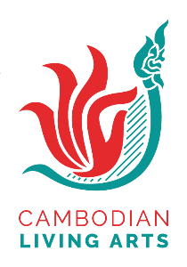
Stand for Culture Fellowship
Application Form

About You

Last & Given Name: Date of birth: ____/____/______
Gender (Please tick the appropriate box): ☐ Male ☐ Female ☐ Prefer not to say ☐ other
Address:
Phone: Email:
Company/Organization: (If you work independently please write ‘not applicable)
Position: (If applicable – no problem if not!)
Organization Address:
Back-up contact name:
Mobile:

Education – Optional to complete

School(s) | Date of Attendance | Qualification | Date of Graduation | Major / Field of Specialization

Previous projects/productions/research in Cambodia related to arts [if any] (Please do not adjust the size of the boxes.)

Brief employment history, beginning with the most recent

Please answers the following questions in the given boxes:

- Why are you interested in Stand for Culture Fellowship?

- What are your expectations by attending Stand for Culture Fellowship?

- Why are you interested in advocacy work?

- What do you think enable effective group-work?

- Please share with us one thing which you wish to see change in the arts sector in Cambodia. In your answer, describe the situation you would like to see changed, why you are not happy with the situation, what you want to see if the situation improves and the ideas you have to make the situation better.

Cambodian Living Arts is committed to supporting the applicants regardless of discrimination, age, disability, indigenous, gender, family status, religion, and socio-economic status. Especially, we encourage candidates from the voiceless communities and we will support them (depending on their needs and necessary). If you wish to share any comments, please type in the box.

You can complete your application by handwriting or computer. If you have any difficulties to be completed the application, please contact to 012 432 201 or email to cci@cambodianlivingarts.org

Checklist
Application form | ☐ Yes
CV / Resume | ☐ Yes

Your signature: Date:

